JOB DESCRIPTION 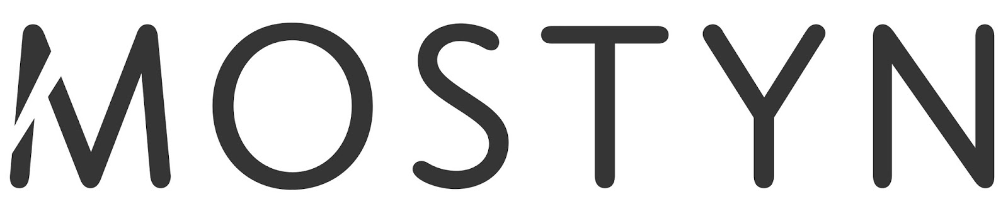
Job title: Kitchen Chef
Reporting to: Cafe Manager
Responsible for: Kitchen/Cafe catering
Minimum contract: 39 hours per week
Salary: £17,000 - £18,252 full time or pro rata [dependant on level of experience]
Job share options are welcomed
Closing date for applications: 5.30pm Monday 5th October 2015
Interview dates: Monday 12th October 2015 / Tuesday 13th October 2015
Main Duties:
Under the direction of the Cafe Manager, creative development of new menus for day-to-day catering and special occasions or events
• Ensuring consistently high standards of food production and presentation within the Cafe
• Ensuring the highest standards of food hygiene, health and safety and environmental health is maintained in the kitchen
• Keep abreast of relevant H&S legislation and the implications on the business, taking action and/or training as required.
• With the Cafe Manager, undertaking food ordering and stocktaking to achieve budgeted food costs and keeping food waste to a minimum
• Regular maintenance and deep cleaning of all catering equipment and plant
• Ensuring the safety and security of kitchens, food stocks and cleaning of all surfaces and cooking utensils during and after food service
• Under the Cafe Manager’s direction, responsible for ensuring the kitchen complies with all Health and Safety regulations
• Undertaking any other reasonable tasks to ensure the successful operation of the Café and Gallery
This is not an exhaustive list of duties. It may be necessary to undertake other reasonable duties for the successful execution of this role and to meet the aims of the organisation.

Furthermore, in common with all post holders, the Chef is expected:-

- To take responsibility for their own and their colleagues' health and safety
- To ensure the security of the gallery and other spaces in MOSTYN
- To act as an advocate of MOSTYN and promote its vision and activities
- To collaborate with all other departments
- To ensure MOSTYN systems, policies and processes are adhered to in the execution of the duties.
Successful applicants will play a key role in ensuring MOSTYN’s visitors enjoy their visit, and will demonstrate a flexible approach to the different responsibilities of the role. They will also provide a high standard of customer service, optimising the potential of income generation and promotion of what MOSTYN has to offer.
Welsh-language ability for this post is not essential but would be seen as an asset.
Hours of work:
39 hours – worked over 6 days [9.30am - 4pm] Working weekends is a compulsory part of this post.
Successful applicants will also be expected to be flexible to cover other staffʼs Annual Leave, and there may an occasional requirement to work unsocial hours in the execution of this role.
How to apply:
E-mail your CV along with a covering letter to Steph Leeder
steph@mostyn.org
(Post applications by prior arrangement only)

Closing date for applications: 5.30pm Monday 5th October 2015
Interview dates: Monday 12th October 2015 / Tuesday 13th October 2015

ABOUT MOSTYN
There's more to MOSTYN than its reputation as the leading gallery of contemporary art in Wales, UK. MOSTYN is the most friendly and inspiring place to experience art and architecture, to eat, to shop, to meet a friend and to learn or do something new.
With views over town and to the sea, Caffi Celf at MOSTYN remains a favourite with our regulars and is a tasty surprise for those who haven’t visited before.
It’s the perfect place to meet for a laid back brunch, lunch or afternoon tea or coffee and home-made cake in bright and airy surroundings. We serve a range of delicious dishes catering for dairy-free, gluten-free, vegan and vegetarian diets, all freshly cooked using simple healthy ingredients. We are fully licensed and serve a range of beers and wine.
www.mostyn.org

