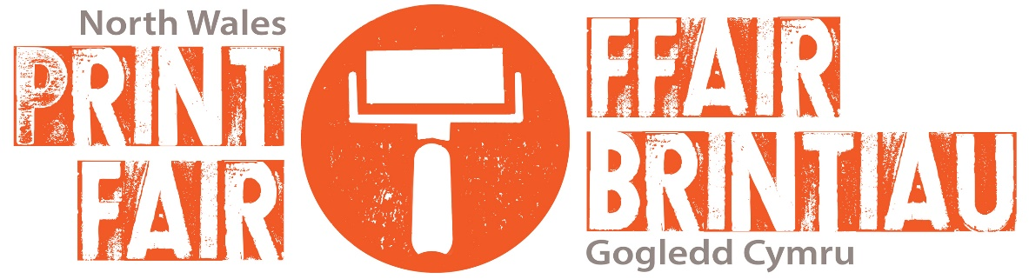
North Wales PRINT FAIR 2020 Application Form:
Name: _________________________________________________________________
Telephone: ______________________________________________________________
Email: __________________________________________________________________
Address: ________________________________________________________________
Website: ________________________________________________________________
Facebook Page: ___________________________________________________________
Twitter: _________________________________________________________________
Instagram:________________________________________________________________
Business / Stand Name: _____________________________________________________
Type of artist: Individual printmaker / Print Studio / Collective / Art Supplier
Price Range: ______________________________________________________________
Type[s] of print /Techniques used: ____________________________________________
Walls: yes / no
[Wall space is optional and subject to availability. Spaces will be allocated at the discretion of MOSTYN.]
Please attach 4x High-Res / Good quality images of your work/merchandise [Optional – 1x Image of previous stall] to your email application [wetransfer, dropbox etc also accepted].
Please also attach a brief artist statement/description of your print technique[s] to your email application.
Please submit your completed application form and requested documentation via email to barry@mostyn.org by 5pm on Tuesday 14th January 2020. Applications without supporting images/statement will not be processed.

We will only hold your data and contact you with regards to the North Wales Print Fair 2020 at MOSTYN. After the event contact details and information will be stored securely for 6 years for audit purposes. We will only contact you with regards to the North Wales Print Fair 2020.
We will not share your details with any third party.

